MANUFACTURING MODULE
To use the Manufacturing Module in ERPNext, the required master data, warehouses, operations, workstations, BOMs, and manufacturing settings must be configured before carrying out production transactions.
The Manufacturing process generally follows this sequence:
Item → BOM → Production Plan → Work Order → Material Transfer → Job Card → Material Consumption → Manufacture → Finished Goods

1. MANUFACTURING MODULE OVERVIEW
The Manufacturing Module is used to manage the process of converting raw materials into finished goods.
Basic Manufacturing Process Flow
Manufacturing Requirement
↓
Production Plan
↓
Work Order
↓
Material Availability Check
↓
Material Transfer to WIP
↓
Production Operations
↓
Job Cards
↓
Material Consumption
↓
Quality Inspection
↓
Manufacture Finished Goods
↓
Finished Goods Warehouse
↓
Production Completion
2. MANUFACTURING PREREQUISITES
Before starting the Manufacturing process, the following configurations should be completed.
Prerequisite Checklist
Company
☐ Company created
☐ Fiscal Year configured
☐ Currency configured
☐ Cost Center configured
☐ Accounting configuration completed

Items
☐ Raw Material Items created
☐ Sub-Assembly Items created where required
☐ Finished Goods Items created
☐ Packing Material Items created where required
☐ Consumable Items created where required
☐ Scrap Items created where required
☐ Item Groups configured
☐ UOM configured
Warehouses
☐ Raw Material Warehouse created
☐ WIP Warehouse created
☐ Finished Goods Warehouse created
☐ Scrap Warehouse created where required
Manufacturing Masters
☐ Workstations created
☐ Operations created
☐ Routing configured where required
☐ BOM created and submitted
Quality
☐ Quality Parameters configured where required
☐ Quality Inspection Templates configured where required
Batch / Serial Number
☐ Batch configuration completed where required
☐ Serial Number configuration completed where required
Settings
☐ Manufacturing Settings reviewed
☐ Stock Settings reviewed
☐ Accounting Settings reviewed
Users
☐ Users created
☐ Roles assigned
☐ Manufacturing permissions configured
☐ Warehouse permissions configured
☐ Quality permissions configured where required

3. CREATING AN ITEM
Items are the basic master records used throughout the Manufacturing process.
Items required for Manufacturing should be created before creating the BOM.
Go to the Item list and click on Add Item. Enter the required Item details.
Save the Item.
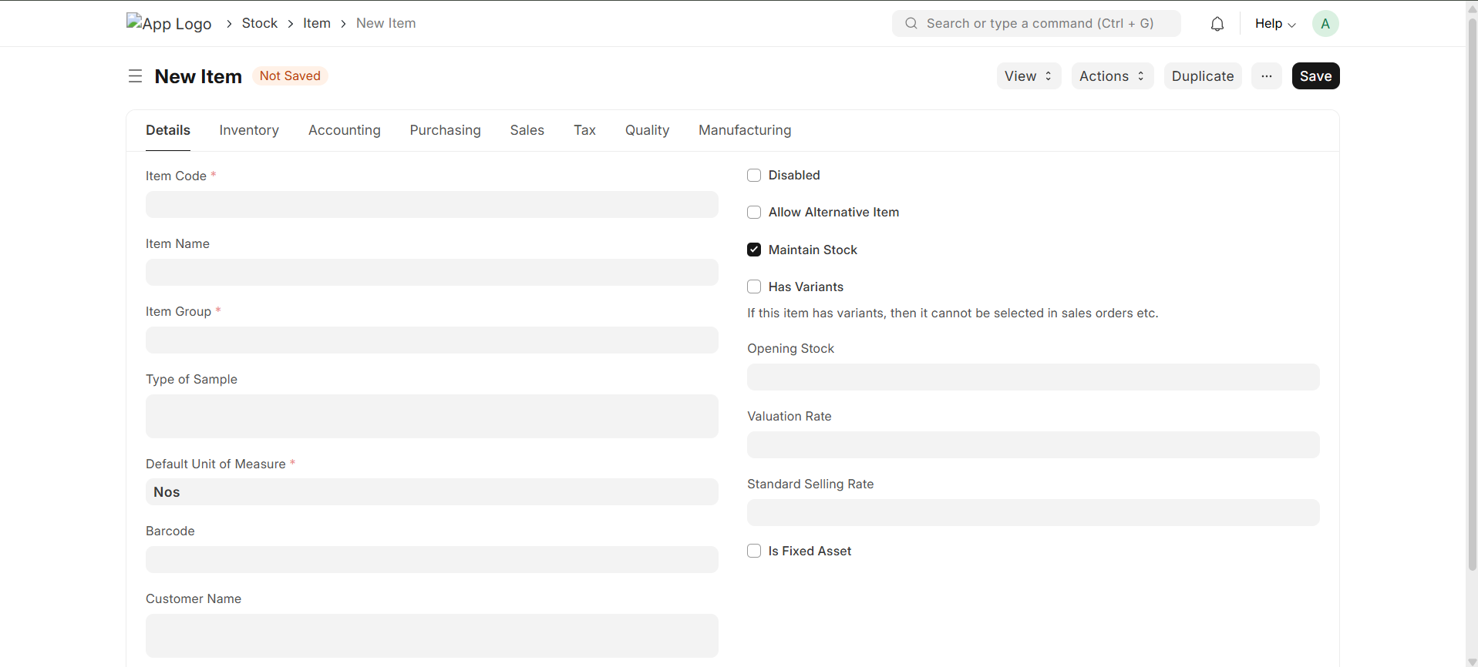
4. ITEM CONFIGURATION CHECKLIST
For each Manufacturing Item, verify:
☐ Item Code
☐ Item Name
☐ Item Group
☐ Stock Item
☐ Stock UOM

5. CREATING A WAREHOUSE
Warehouses are required to manage the movement of raw materials, work-in-progress materials, finished goods, and scrap.
Navigate from Home to the Warehouse.
Click on Add Warehouse.
Enter the Warehouse Name.
Select the appropriate Parent Warehouse where required.
Save the Warehouse.
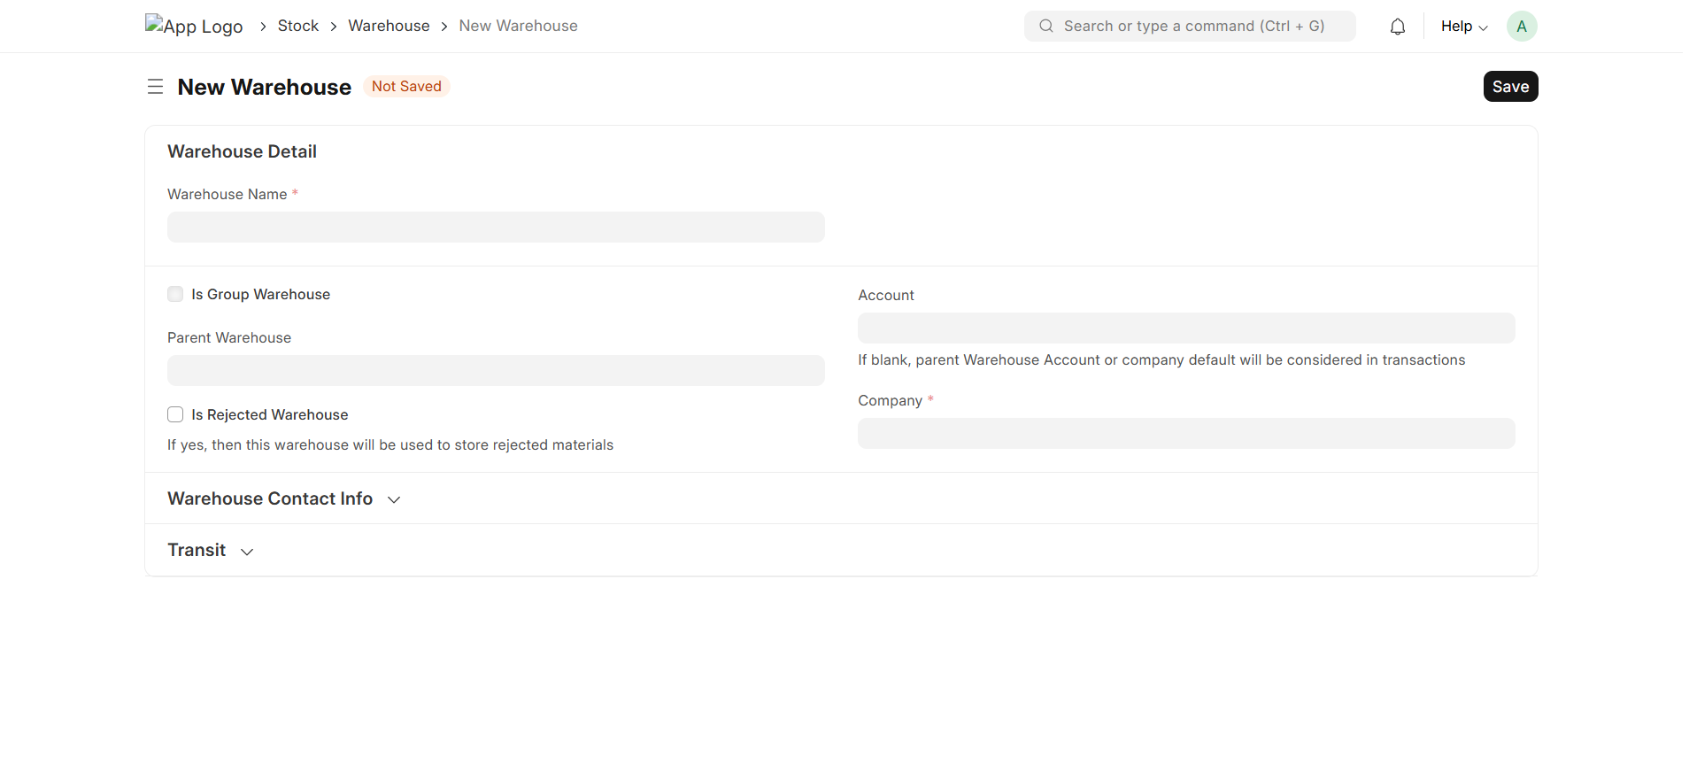
6. MANUFACTURING WAREHOUSE STRUCTURE
The following warehouse categories should be configured according to the organization's manufacturing process:
- Raw Material Warehouse
- Packing Material Warehouse
- WIP Warehouse
- Finished Goods Warehouse
- Scrap Warehouse
The warehouse structure should be finalized before production transactions begin.

7. CREATING A WORKSTATION
A Workstation represents the machine, production station, or production resource where an operation is performed.
Navigate from Home to the Manufacturing Module and go to Workstation.
Click on Add Workstation.
Enter the required Workstation details.
Configure the working hours and capacity where required.
Configure the operating cost where required.
Save the Workstation.
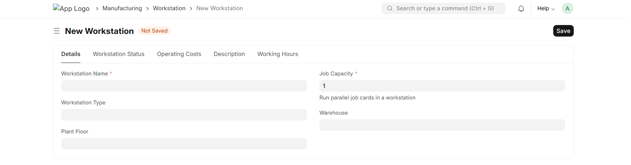
8. WORKSTATION CHECKLIST
☐ Workstation Name
☐ Working Hours
☐ Holiday List where required
☐ Production Capacity
☐ Operating Cost
☐ Hourly Cost where applicable
☐ Workstation availability verified

9. CREATING AN OPERATION
An Operation represents an individual activity that is performed during the manufacturing process.
Navigate from Home to the Manufacturing Module and go to Operation.
Click on Add Operation.
Enter the Operation Name.
Select the appropriate Workstation.
Configure the operation duration where required.
Configure Quality Inspection requirements where required.
Save the Operation.
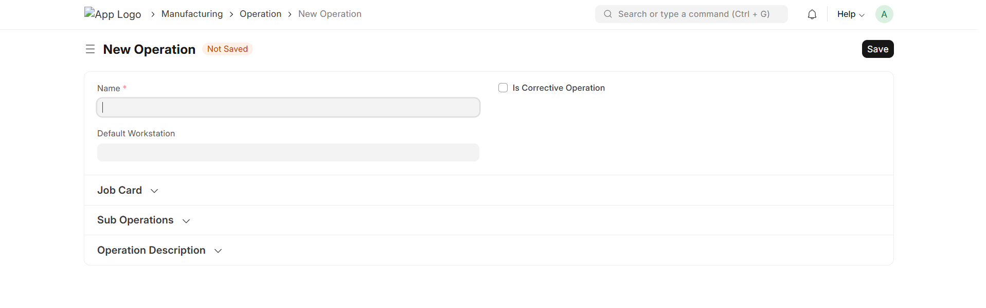
10. OPERATION CHECKLIST
☐ Operation Name
☐ Operation Description
☐ Workstation
☐ Operation Time
☐ Quality requirements where applicable
☐ Operation sequence identified

11. CREATING A ROUTING
Routing is used to define the sequence of Operations required to manufacture an Item.
Navigate from Home to the Manufacturing Module and go to Routing.
Click on Add Routing.
Enter the required Routing details.
Add the required Operations.
Set the sequence of Operations.
Select the appropriate Workstations where required.
Save the Routing.
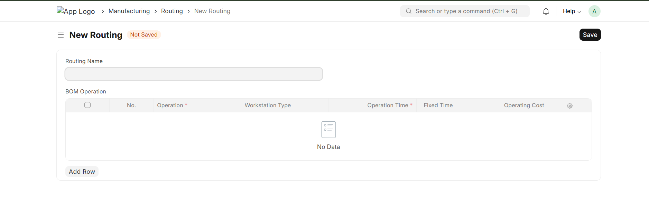
12. CREATING A BILL OF MATERIAL (BOM)
A Bill of Material defines the materials and operations required to manufacture an Item.
The BOM is one of the most important documents in the Manufacturing process.
Navigate from Home to the Manufacturing Module and go to BOM.
Click on Add BOM.
Select the Finished Item.
Enter the required quantity.
Add the required Raw Materials in the Items table.
Enter the required quantities.
Select the required Source Warehouse.
Add Operations where required.
Select the appropriate Workstations.
Verify the BOM.
Save and Submit the BOM.
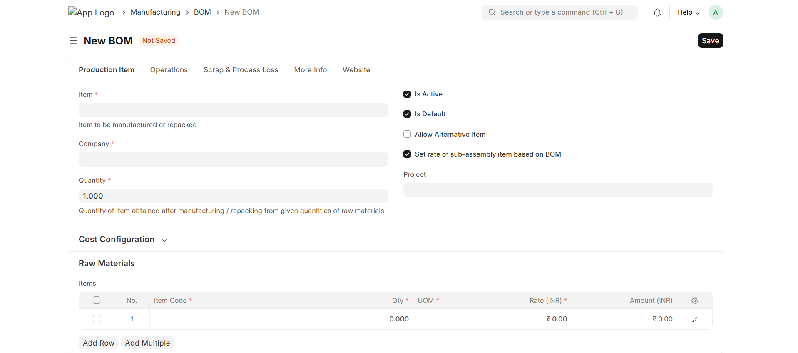
13. BOM CHECKLIST
Before submitting the BOM, verify:
☐ Finished Item
☐ BOM Quantity
☐ Raw Materials
☐ Material Quantities
☐ UOM
☐ Source Warehouse
☐ Operations
☐ Workstations
☐ Operation Sequence
☐ Operation Time
☐ Scrap where applicable
☐ Routing where applicable
☐ Sub-Assembly requirements
☐ Batch/Serial requirements
☐ BOM Cost
Save and Submit the BOM after verification.

14. MULTI-LEVEL BOM
A Multi-Level BOM is used when an Item contains Sub-Assemblies that have their own BOMs.
Before creating a Multi-Level Manufacturing process, verify:
☐ Sub-Assembly Item exists
☐ Sub-Assembly BOM exists
☐ Parent Item exists
☐ Parent BOM exists
☐ Sub-Assembly quantity is correct
☐ Production sequence is defined
☐ Warehouse requirements are defined

15. MANUFACTURING SETTINGS
Manufacturing Settings control various aspects of the Manufacturing process.
Navigate from Home to the Manufacturing Module and go to Manufacturing Settings under the Settings section.
Review the available Manufacturing settings.
Configure the settings according to the organization's manufacturing process.
The following should be reviewed:
- Default WIP Warehouse
- Default Finished Goods Warehouse
- Default Scrap Warehouse where applicable
- Material Consumption settings
- Backflush settings
- Capacity Planning
- Operation-related settings
- Stock-related Manufacturing settings
Save the settings after verification.
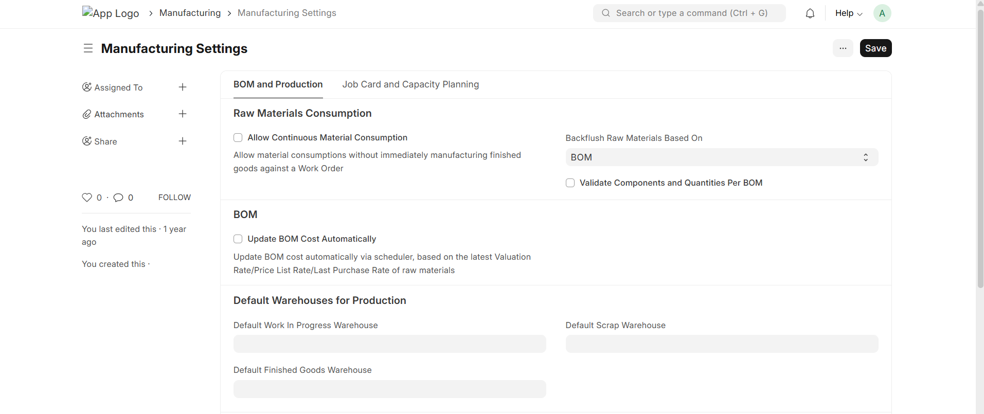
16. OPENING STOCK
Before starting Manufacturing, the required Raw Materials should be available in the appropriate Warehouse.
Verify:
☐ Raw Material stock
☐ Packing Material stock
☐ Sub-Assembly stock where applicable
☐ Existing Finished Goods stock
☐ Warehouse-wise stock
☐ Batch information where applicable
☐ Serial Number information where applicable
☐ Stock valuation

17. PRODUCTION PLAN
A Production Plan is used to organize and plan the Items that need to be manufactured.
Navigate from Home to the Manufacturing Module and go to Production Plan.
Click on Add Production Plan.
Select the required Items.
Enter the required production quantity.
Enter the required date.
Verify the BOM.
Review the Material Requirements.
Review the existing stock and material availability.
Save and Submit the Production Plan.
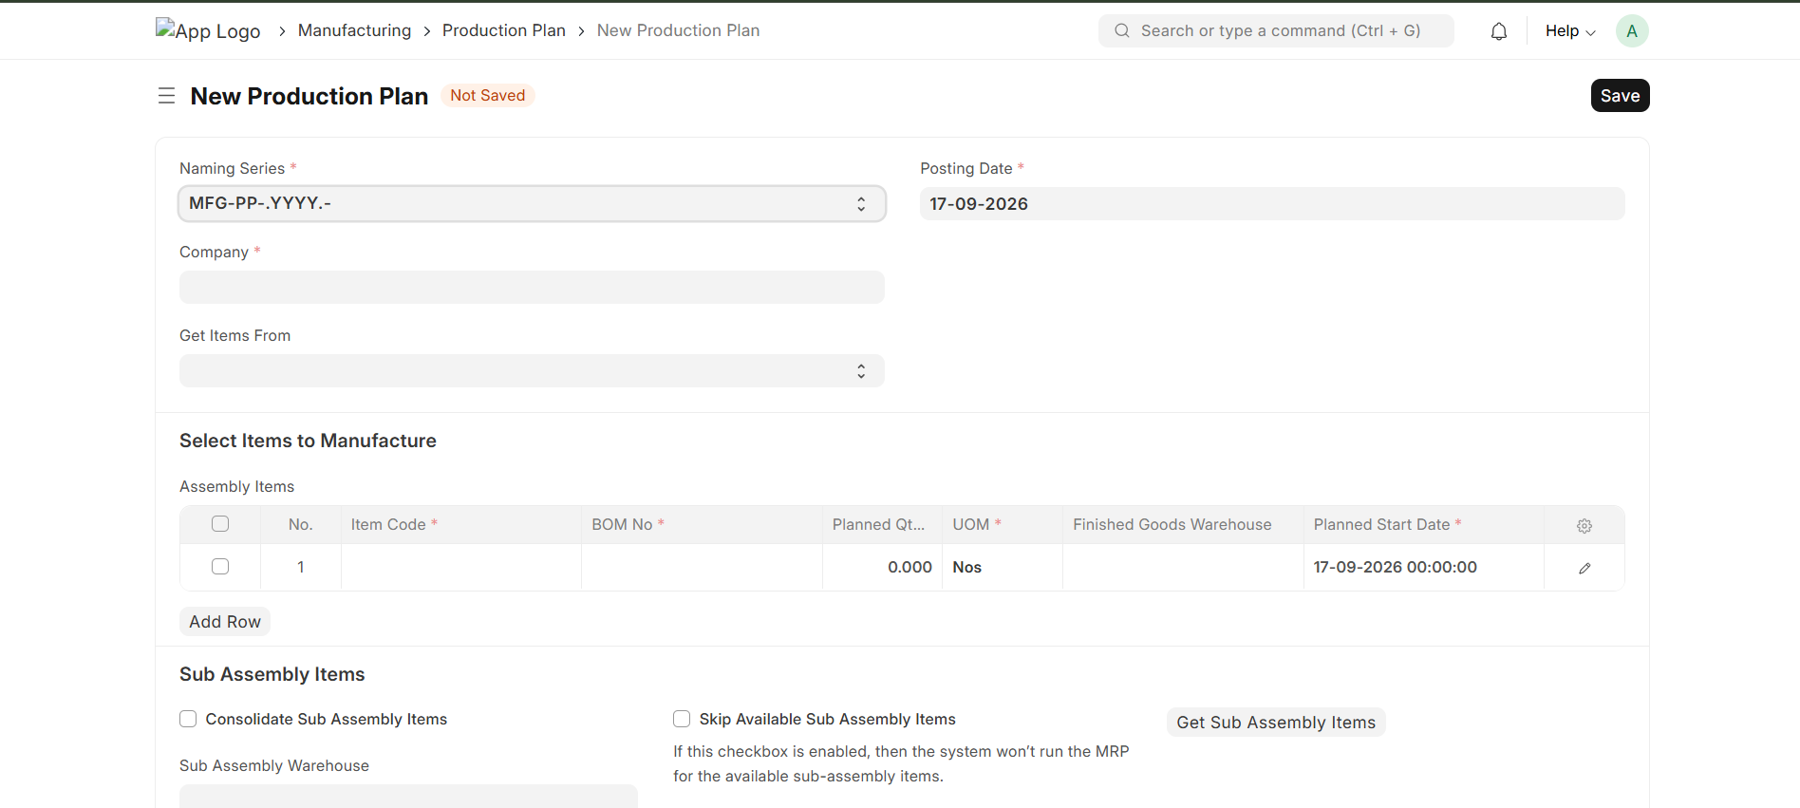
18. PRODUCTION PLAN CHECKLIST
☐ Finished Item selected
☐ Production Quantity entered
☐ Required Date entered
☐ BOM verified
☐ Material Requirements reviewed
☐ Existing Stock reviewed
☐ Sub-Assembly requirements reviewed
☐ Production requirements verified
☐ Production Plan submitted

19. CREATING A WORK ORDER
A Work Order is used to authorize and manage the production of a specific quantity of an Item.
A Work Order can be created from the Production Plan or according to the organization's Manufacturing process.
Navigate from Home to the Manufacturing Module and go to Work Order.
Click on Add Work Order.
Select the Finished Item.
Select or verify the BOM.
Enter the production quantity.
Verify the required materials.
Verify the Operations.
Verify the Workstations.
Verify the Source Warehouse and WIP Warehouse.
Verify the Finished Goods Warehouse.
Save and Submit the Work Order.
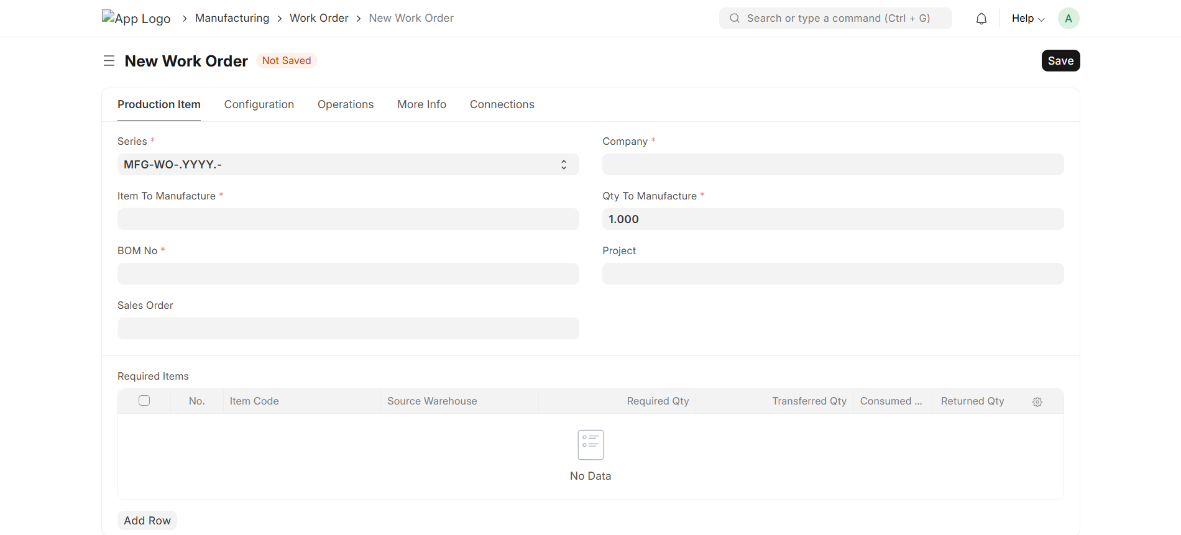
20. WORK ORDER CHECKLIST
Before submitting the Work Order:
☐ Finished Item
☐ BOM
☐ Production Quantity
☐ Required Date
☐ Source Warehouse
☐ WIP Warehouse
☐ Finished Goods Warehouse
☐ Raw Materials
☐ Material Quantities
☐ Operations
☐ Workstations
☐ Batch/Serial requirements
☐ Scrap requirements
☐ Work Order submitted

21. MATERIAL AVAILABILITY
After creating the Work Order, verify whether the required materials are available.
The material availability should be checked before starting production.
Required Materials
↓
Check Stock
↓
Material Available?
/ \
Yes No
↓ ↓
Proceed Arrange Material
If the required material is not available, follow the organization's approved procurement, transfer, or replenishment process.

22. MATERIAL TRANSFER TO WIP
Material Transfer is used to move the required Raw Materials from the source Warehouse to the WIP Warehouse.
From the Work Order, use the appropriate Create option to create the Material Transfer Stock Entry.
Verify:
- Source Warehouse
- WIP Warehouse
- Items
- Quantities
- Batch information
- Serial Numbers where applicable
Save and Submit the Stock Entry.

23. MATERIAL TRANSFER CHECKLIST
☐ Work Order verified
☐ Source Warehouse verified
☐ WIP Warehouse verified
☐ Items verified
☐ Quantity verified
☐ Batch verified where applicable
☐ Serial Numbers verified where applicable
☐ Stock Entry reviewed
☐ Stock Entry submitted
☐ WIP stock verified

24. JOB CARD
A Job Card records the execution of a Manufacturing Operation.
Job Cards are generally created from the Work Order for the Operations defined in the BOM.
Open the required Job Card.
Verify the:
- Work Order
- Operation
- Workstation
- Employee
- Start Time
- End Time
- Completed Quantity
- Rejected Quantity
Record the required production information.
Complete and Submit the Job Card according to the configured process.
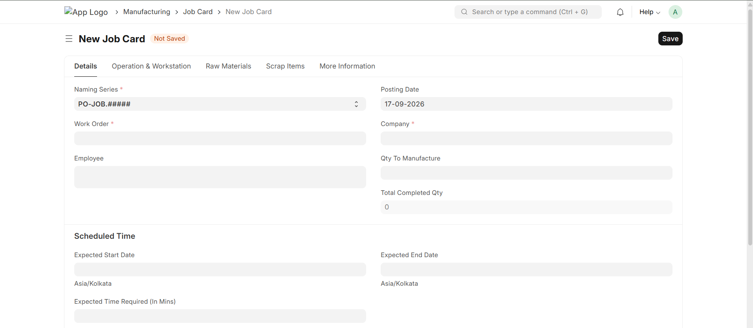
25. JOB CARD CHECKLIST
☐ Work Order verified
☐ Operation verified
☐ Workstation verified
☐ Employee assigned where required
☐ Start Time recorded
☐ End Time recorded
☐ Completed Quantity recorded
☐ Rejected Quantity recorded where applicable
☐ Time Log verified
☐ Remarks added where required
☐ Job Card completed

26. PRODUCTION OPERATIONS
Production Operations should be performed according to the sequence defined in the BOM or Routing.
The process is:
Work Order
↓
Operation 1
↓
Job Card
↓
Operation Completed
↓
Operation 2
↓
Job Card
↓
Operation Completed
↓
Next Operation
Each Operation should be completed according to the organization's production process.

27. MATERIAL CONSUMPTION
During production, the actual Raw Materials consumed should be recorded.
The planned quantity should be compared with the actual quantity consumed.
Planned Quantity
↓
Actual Quantity
↓
Quantity Variance
Verify:
☐ Planned quantity
☐ Actual quantity
☐ Excess consumption
☐ Short consumption
☐ Wastage
☐ Material variance
Record the consumption according to the configured Manufacturing process.

28. REJECTED PRODUCTION
If production is rejected during Quality Inspection, follow the organization's approved procedure.
The possible actions may include:
Quality Inspection
↓
Rejected
↓
┌─────┼─────┐
↓ ↓ ↓
Rework Scrap Hold
The appropriate action should be recorded in ERPNext.
Verify:
☐ Rejected Quantity
☐ Rework requirement
☐ Scrap requirement
☐ Additional Material
☐ Additional Operations
☐ Re-inspection requirement

29. MANUFACTURE ENTRY
The Manufacture transaction is used to record the production of Finished Goods and the corresponding consumption of materials.
From the Work Order, use the appropriate Create option to create the Manufacture transaction.
Verify:
- Finished Item
- Finished Quantity
- Consumed Materials
- WIP Warehouse
- Finished Goods Warehouse
- Scrap
- Batch information
- Serial Numbers
Review the transaction carefully.
Save and Submit the Manufacture transaction.

30. MANUFACTURE ENTRY CHECKLIST
☐ Work Order verified
☐ Finished Item verified
☐ Finished Quantity verified
☐ Consumed Materials verified
☐ Material Quantity verified
☐ WIP Warehouse verified
☐ Finished Goods Warehouse verified
☐ Scrap verified
☐ Batch verified where applicable
☐ Serial Numbers verified where applicable
☐ Manufacture Entry reviewed
☐ Manufacture Entry submitted

34. FINISHED GOODS
After the Manufacture Entry is submitted, the Finished Goods should be available in the designated Finished Goods Warehouse.
Verify the Finished Goods stock.
Check:
☐ Finished Goods quantity
☐ Finished Goods Warehouse
☐ Batch information
☐ Serial Numbers
☐ Stock Balance
☐ Stock Ledger

35. PRODUCTION COMPLETION
After completing the production process, verify that all related transactions have been completed.
The final process should be:
Work Order
↓
Material Transfer
↓
Job Cards
↓
Material Consumption
↓
Quality Inspection
↓
Manufacture Entry
↓
Finished Goods
↓
Production Completion
Verify:
☐ Work Order status
☐ Job Cards
☐ Material Consumption
☐ Finished Goods
☐ Scrap
☐ Quality Inspection
☐ Batch/Serial information
☐ Stock Balance
☐ Stock Ledger
☐ Manufacturing Cost
☐ Accounting impact

36. PARTIAL PRODUCTION
If production is completed partially, verify the completed quantity and remaining quantity.
The process should ensure that:
☐ Completed quantity is recorded correctly
☐ Remaining quantity is identified
☐ Material consumption is correct
☐ Finished Goods quantity is correct
☐ Job Cards are updated
☐ Remaining Work Order quantity is tracked

37. SCRAP
Scrap generated during Manufacturing should be recorded according to the organization's process.
Verify:
☐ Scrap Item
☐ Scrap Quantity
☐ Scrap Warehouse
☐ Scrap valuation
☐ Scrap accounting impact

38. REWORK
When rejected production requires additional processing, the rework process should be followed.
Production
↓
Quality Inspection
↓
Rejected
↓
Rework
↓
Additional Processing
↓
Quality Inspection
↓
Accepted / Rejected
Verify:
☐ Rework requirement
☐ Additional material
☐ Additional operations
☐ Additional cost
☐ Re-inspection
☐ Final status

39. BATCH MANUFACTURING
For Batch-controlled Manufacturing Items, verify the Batch information at each required stage.
The process includes:
Raw Material Batch
↓
Material Consumption
↓
Manufacturing
↓
Finished Goods Batch
Verify:
☐ Raw Material Batch
☐ Batch Quantity
☐ Batch Consumption
☐ Finished Goods Batch
☐ Batch Traceability

40. SERIAL NUMBER MANUFACTURING
For Serial Number-controlled Items, verify Serial Numbers throughout the Manufacturing process.
Verify:
☐ Raw Material Serial Numbers where applicable
☐ Serial Number consumption
☐ Finished Goods Serial Numbers
☐ Serial Number quantity
☐ Serial Number traceability

41. MULTI-LEVEL MANUFACTURING
For Manufacturing processes involving Sub-Assemblies:
Sub-Assembly
↓
Sub-Assembly Production
↓
Sub-Assembly Stock
↓
Parent Production
↓
Finished Goods
Verify:
☐ Sub-Assembly BOM
☐ Parent BOM
☐ Sub-Assembly production
☐ Material availability
☐ Work Orders
☐ WIP movement
☐ Finished Goods production

42. MANUFACTURING COST VERIFICATION
After Manufacturing, verify the production cost.
The cost may include:
- Raw Material Cost
- Operation Cost
- Labour-related cost where configured
- Workstation/Machine Cost
- Additional Manufacturing Cost
- Scrap/recovery impact where applicable
Verify:
☐ Raw Material Cost
☐ Operation Cost
☐ Actual Production Cost
☐ Additional Cost
☐ Planned Cost
☐ Actual Cost
☐ Cost Variance

43. STOCK VERIFICATION
After completing Manufacturing, verify the stock impact.
Check:
Raw Materials
☐ Required Raw Materials consumed correctly
☐ Warehouse stock updated correctly
WIP
☐ WIP stock updated correctly
☐ WIP balance verified
Finished Goods
☐ Finished Goods received correctly
☐ Correct Warehouse
☐ Correct quantity
Scrap
☐ Scrap quantity recorded
☐ Scrap Warehouse updated

44. STOCK LEDGER VERIFICATION
Open the Stock Ledger and verify the Manufacturing transactions.
Verify:
☐ Raw Material stock reduction
☐ WIP stock movement
☐ Finished Goods stock increase
☐ Scrap movement
☐ Batch information
☐ Serial Number information where applicable
☐ Valuation Rate
☐ Stock Value

45. ACCOUNTING VERIFICATION
Manufacturing transactions may have an accounting impact.
Verify:
☐ Stock valuation
☐ Material valuation
☐ Manufacturing cost
☐ Operation cost
☐ Additional cost
☐ Accounting entries
☐ Cost variance
Accounting verification should be performed according to the organization's accounting process.

46. MANUFACTURING REPORTS
The Manufacturing process can be monitored using relevant ERPNext reports.
Reports and information that may be reviewed include:
- Work Orders
- Job Cards
- Stock Balance
- Stock Ledger
- Batch information
- Serial Number information
- BOM Cost
- Production information
- Material consumption
- Manufacturing cost
- Production variance
The required reports should be identified according to the organization's reporting requirements.

47. MANUFACTURING DOCUMENT STATUS
Users should understand the status of Manufacturing documents before taking further action.
Common statuses include:
Draft
The document has been saved but has not yet been submitted.
Submitted
The document has been submitted and its transaction has been recorded.
In Progress
The Manufacturing process is currently being executed.
Completed
The required Manufacturing process has been completed.
Stopped
The Manufacturing process has been stopped before completion.
Cancelled
The document has been cancelled.
The exact statuses available may vary depending on the ERPNext document and configuration.

48. EXCEPTION HANDLING
The following situations should be handled according to the organization's approved correction process:
- Raw Material not available
- Wrong BOM
- Wrong Material Quantity
- Wrong Warehouse
- Wrong Batch
- Wrong Serial Number
- Excess Material Consumption
- Short Material Consumption
- Production Rejection
- Partial Production
- Scrap
- Rework
- Incorrect Finished Goods Quantity
- Incorrect Production Transaction
- Manufacturing Cancellation
Before correcting a submitted transaction, check all related documents and stock/accounting impact.

49. CANCELLATION AND CORRECTION
Before cancelling or correcting a Manufacturing transaction, review its dependent transactions.
The document relationship should be checked in the following order:
Work Order
↓
Material Transfer
↓
Job Card
↓
Material Consumption
↓
Quality Inspection
↓
Manufacture Entry
Before making corrections:
☐ Identify incorrect document
☐ Identify dependent transactions
☐ Check stock impact
☐ Check accounting impact
☐ Obtain required approval
☐ Cancel/reverse transactions according to ERPNext rules
☐ Correct the required transaction
☐ Recreate transaction where required
☐ Verify stock
☐ Verify accounting
☐ Verify Work Order status

50. FINAL MANUFACTURING CHECKLIST
Before Manufacturing
☐ Company configured
☐ Accounting configured
☐ Items created
☐ Item Groups configured
☐ UOM configured
☐ Warehouses configured
☐ Workstations configured
☐ Operations configured
☐ Routing configured where required
☐ BOM created
☐ Quality configured where required
☐ Batch/Serial configured where required
☐ Manufacturing Settings configured
☐ Users configured
☐ Permissions configured
☐ Opening Stock verified

Production Planning
☐ Production requirement identified
☐ Production quantity identified
☐ Required date identified
☐ BOM verified
☐ Material availability checked
☐ Production capacity checked
☐ Production Plan completed where applicable

Work Order
☐ Finished Item verified
☐ BOM verified
☐ Production Quantity verified
☐ Materials verified
☐ Operations verified
☐ Workstations verified
☐ Warehouses verified
☐ Work Order submitted

Material Transfer
☐ Material availability confirmed
☐ Source Warehouse verified
☐ WIP Warehouse verified
☐ Quantity verified
☐ Batch/Serial verified
☐ Stock Entry submitted
☐ WIP stock verified

Production
☐ Job Cards created
☐ Operations completed
☐ Employee assigned where required
☐ Production quantity recorded
☐ Rejected quantity recorded where applicable
☐ Material Consumption completed
☐ Material variance reviewed

Quality
☐ Quality Inspection completed
☐ Quality parameters verified
☐ Accepted quantity verified
☐ Rejected quantity verified
☐ Rework completed where applicable

Finished Goods
☐ Manufacture Entry created
☐ Finished Item verified
☐ Finished Quantity verified
☐ Material Consumption verified
☐ WIP Warehouse verified
☐ Finished Goods Warehouse verified
☐ Scrap verified
☐ Batch/Serial verified
☐ Manufacture Entry submitted
☐ Finished Goods stock verified

Final Verification
☐ Work Order completed
☐ Job Cards completed
☐ Material Consumption verified
☐ Finished Goods verified
☐ Scrap verified
☐ Quality completed
☐ Stock Ledger verified
☐ Stock Balance verified
☐ Batch/Serial traceability verified
☐ Manufacturing Cost verified
☐ Accounting impact verified

51. COMPLETE MANUFACTURING PROCESS FLOW
MANUFACTURING REQUIREMENT
↓
PRODUCTION PLAN
↓
WORK ORDER
↓
MATERIAL AVAILABILITY
↓
MATERIAL TRANSFER TO WIP
↓
PRODUCTION OPERATIONS
↓
JOB CARDS
↓
MATERIAL CONSUMPTION
↓
QUALITY INSPECTION
↓
MANUFACTURE ENTRY
↓
FINISHED GOODS
↓
STOCK VERIFICATION
↓
COST & ACCOUNTING CHECK
↓
PRODUCTION COMPLETION

52. MANUFACTURING GO-LIVE CHECKLIST
Before starting live Manufacturing transactions:
Master Data
☐ Items verified
☐ UOMs verified
☐ Warehouses verified
☐ Workstations verified
☐ Operations verified
☐ Routings verified
☐ BOMs verified
☐ Quality configuration verified
☐ Batch/Serial configuration verified
System Configuration
☐ Manufacturing Settings verified
☐ Stock Settings verified
☐ Accounting Settings verified
☐ Company configuration verified
☐ User permissions verified
Process Testing
☐ Production Plan tested
☐ Work Order tested
☐ Material Transfer tested
☐ Job Card tested
☐ Material Consumption tested
☐ Quality Inspection tested
☐ Manufacture Entry tested
☐ Scrap tested where applicable
☐ Batch tested where applicable
☐ Serial Number tested where applicable
☐ Partial Production tested where applicable
☐ Multi-Level BOM tested where applicable
Final Validation
☐ Stock impact verified
☐ Accounting impact verified
☐ Manufacturing cost verified
☐ Reports verified
☐ User training completed
☐ UAT completed
☐ Business approval obtained
☐ Go-Live approved

